**Elaboration Phase Prototype**

The following pages contain the prototypes representing potential views the actor, in this case, the customer or Karoline will have when completing actions on her site or sites related to the overall system. In other words, they are interfaces that represent all of the use cases we have created. Some of the tasks share common interfaces and will be noted on the specific interface when they do. Each prototype contains some details below it providing a brief explanation. In-depth details about each prototype are provided in their respective use case specifications.

**Customer Account Creation Form- Use Case 1 Prototype**

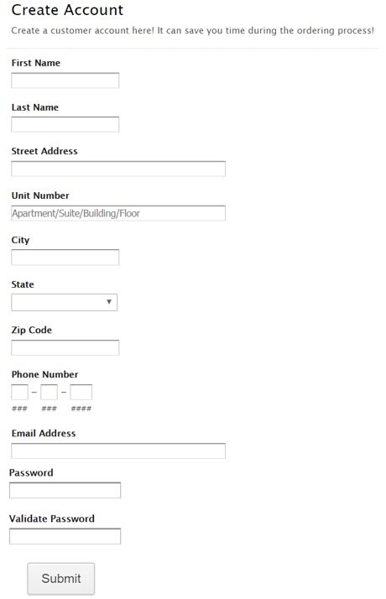

**Figure 1**

* Customers can create an account by entering their information in the above fields.
* The customer’s data will be stored within the database.
* Creating an account can allow the customer to order items easily without having to re-input previous information. Additionally, it provides Karoline with a centralized view of a customer.

**Update Customer- Use Case 2 and Sign-In Customer- Use Case 36 Prototype**

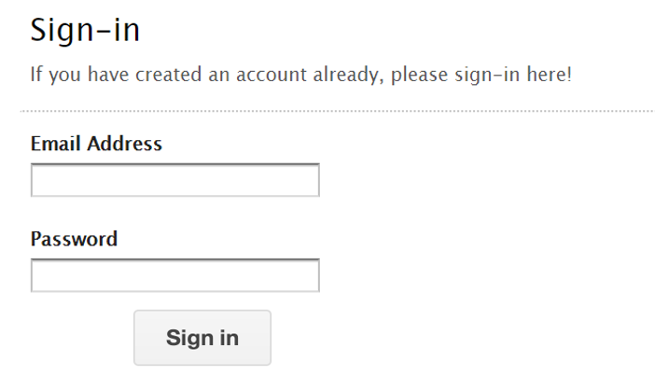

**Figure 2**

* To allow customers the ability to update their account information, the customer will sign-in to Karoline’s website first.
* Then the customer can update account information displayed in the customer account creation form for use case 1.

**Sign-Out Customer-Use Case 37 Prototype**

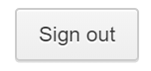

**Figure 3**

* In order for the customer to sign out they will have to click the sign out button on Karoline’s website.

**Use Cases 3, 4 - 6, 8, 9, 11 - 27, 30 - 36 Prototype**

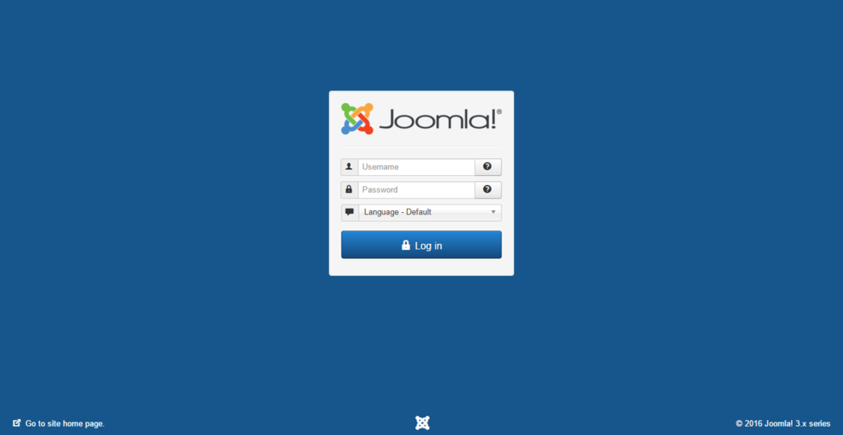

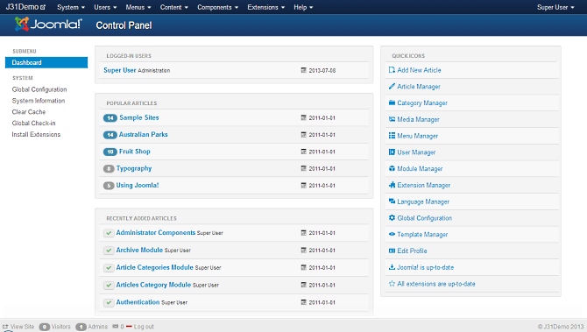

**Figure 4**

* The same prototype is used for multiple use cases because they share the same screen view.
* These use cases primarily involve simple CRUD (Create, Read, Update, Delete) operations. Karoline can use the Joomla! CMS to accomplish these tasks in a single, straightforward interface.

**Customer Data Form- Use Case 7 Prototype**

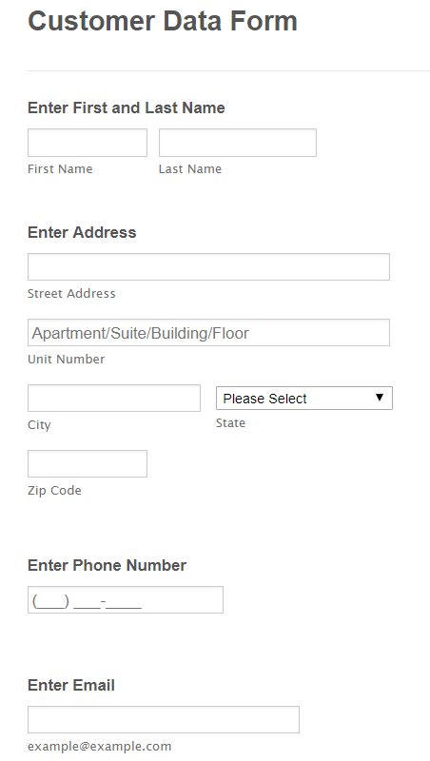

**Figure 5**

* If a customer is checking out as a guest, they will have to enter in the above information while creating their order.
* It allows Karoline to associate an order with a customer as well as use their information for marketing purposes.
* If a customer is signed in to their account, this data will be pre-populated.

**Order Form- Use Case 7 Prototype (Customer selects card as Payment Type)**

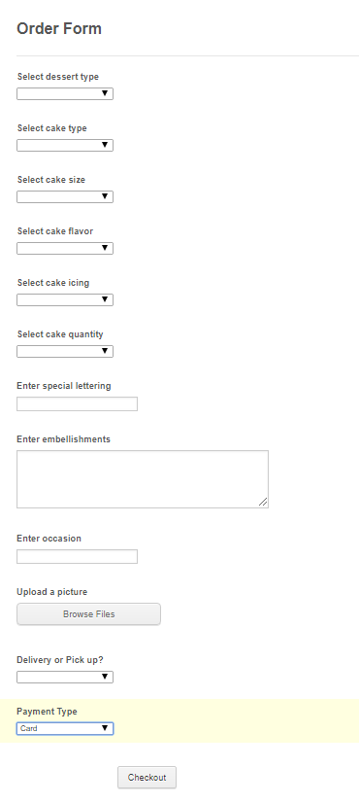

**Figure 6**

* Fields to enter in information about the cake
  + Includes specifics on type, size, flavor, icing, etc.
* Option to upload a picture
* Additional fields could be added easily to capture more information
* The goal of such a form is to cut down on the need to communicate with customers and simplify the order process for Karoline and her customers.
* If customer selects card, they click the checkout button.

**Order Form- Use Case 7 Prototype (Customer selects cash or check as Payment Type)**

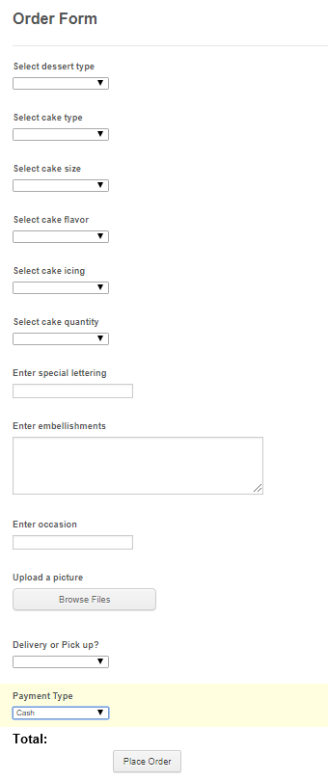

**Figure 7**

* If the customer selects cash or check, they select the place order button.
* Their total is displayed as well.

**Order Available Cake from Product Page- Use Case 7 Alternative Flow Prototype**

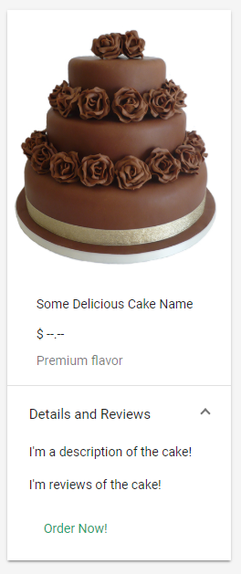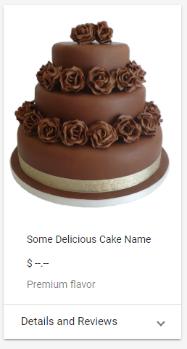

**Figure 8**

* Display available cakes with sample images
* The customer can order a cake that has been previously made by Karoline.
* Functions as an FAQ/Product Inquiry destination
* It can include cake pricing and reviews from previous customers that easily toggle between being shown or not.
* It presents Karoline’s work for customer affirmation, as well as it saves time for individual questions.

**Create Payment- Use Case 38 Prototype (Customer pays with card) (Use Case 7 Extension Point)**

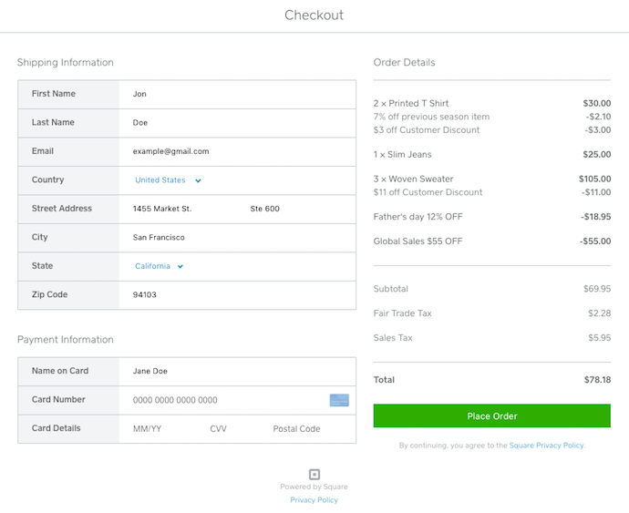

**Figure 9**

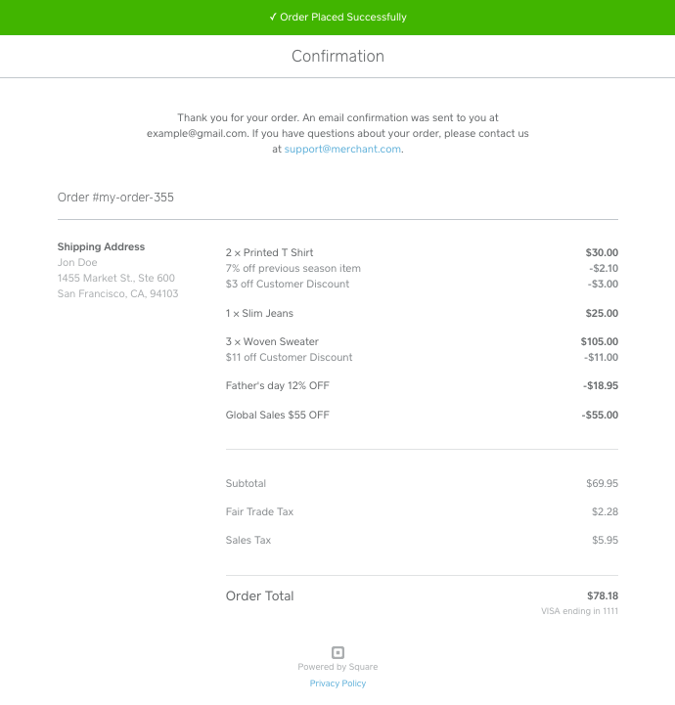

**Figure 10**

* Once the customer clicks checkout they will be taken to Square’s website.
* Customers will enter payment details on Square’s hosted checkout.
* Once customers place their order they will be taken to a confirmation page also on Square’s website.
* If the customer selects cash or check as their payment type while creating their order, they will deal with Karoline directly for payment.

**Use Case 39 and 40 Prototype (Customer paid with card)**

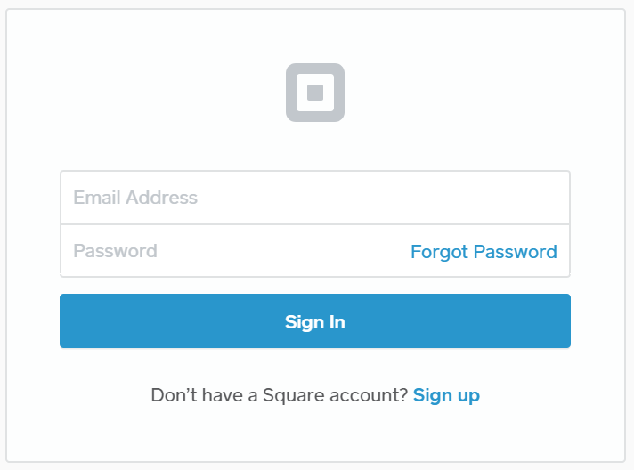

**Figure 11**

* **Use Case 39-Update Payment**
  + Karoline will sign-in to her Payment Management System administrator account, in this case Square.
  + From there, Karoline will navigate to the appropriate section to update the customer’s payment.
  + The change will be reflected in the database as well as to the customer.
* **Use Case 40**-**Delete Payment**
  + Karoline will sign-in to her Payment Management System administrator account, in this case Square.
  + From there, Karoline will navigate to the appropriate refund section on her Square dashboard.
  + The change will be reflected in the database as well as to the customer.

**Use Case 33,34 and 35 Prototype (Create, Update, and Delete expenses in Square account)**

***Note: this is the only available preview of Square’s expense tracking system, the up to date model may contain more attributes per expense record - all subsequent diagram attributes were derived from this preview, but may change depending on the now available feature***

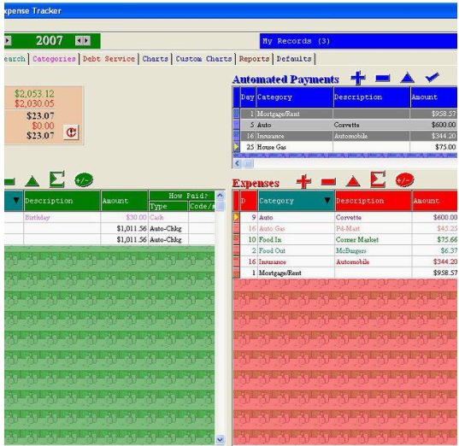

(<https://squareup.com/market/almsys-inc/monthly-income-expense-tracker>)

* **Use Case 33**-**Create Expense**
  + Karoline will sign-in to her Payment Management System administrator account, in this case Square.
  + From there, Karoline will navigate to the expense section of her Square account.
  + Karoline may create a line item containing cost, category, and description of any expense she may have and wish to keep track of
* **Use Case 34**-**Update Expense**
  + Karoline will sign-in to her Payment Management System administrator account, in this case Square.
  + From there, Karoline will navigate to the expense section of her Square account.
  + Karoline may update a line item’s cost, category, and description
* **Use Case 35**-**Delete Expense**
  + Karoline will sign-in to her Payment Management System administrator account, in this case Square.
  + From there, Karoline will navigate to the expense section of her Square account.
  + Karoline may delete a line item of a previously created line item in case of misentry, the item was returned/refunded, etc.